**Instruction**

**Please use the Data.xlsx file to investigate the effect of independent variables (price per square foot, number of bathrooms, and floor size) on the price of a high-floor, spacious 2-bedroom house with a spectacular view, available at an affordable price. The null hypothesis (H0) states that there is no significant effect of the independent variables on the price. The alternative hypothesis (H1) suggests that there is a significant effect of the independent variables on the price. The objective is to test this hypothesis using the provided data in the "Data" Excel file.**

1. **Selection of Confidence Level: A 95% confidence level is chosen to determine the range within which the true parameter value is likely to fall. A 95% confidence interval covers 95% of the normal curve, meaning that there is a 5% probability of observing a value outside of this range.**

**Answer :**

Lower Bound Upper Bound

const -100055.894814 -95061.634803

PRICE_SQFT 1346.853913 1390.495599

NO_OF_BATHROOMS 13.784914 980.195114

FLOOR_SIZE 68.425244 70.973347

1. **Statistical Test or Model: To test the hypothesis, a multiple regression analysis is conducted. This analysis helps determine the relationship between the dependent variable (price) and the independent variables (price per square foot, number of bathrooms, and floor size**

**Answer :**

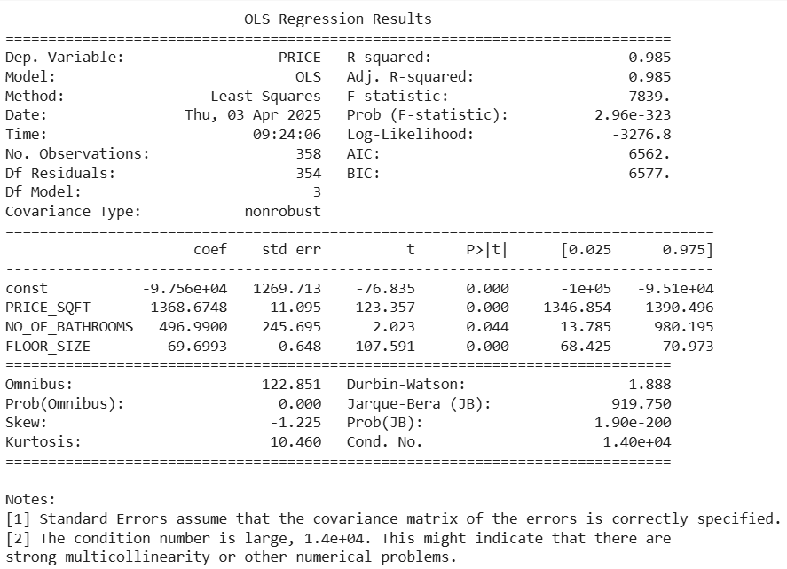

* Null Hypothesis (H0): The independent variables do not significantly affect the house price.
* Alternative Hypothesis (H1): The independent variables do significantly affect the house price.

Key statistics to checked:

1. P-values: 0.044
   * If p < 0.05, the variable is statistically significant.
   * If p > 0.05, the variable is not significant.
2. R-squared value:
   * 0.985 is Higher values indicate better model fit.
3. F-statistic:
   * 7839 which Determines if the overall model is statistically significant.

We have all independent variables have p-values < 0.05, we reject H0 and conclude that price per square foot, number of bathrooms, and floor size significantly affect house price.